Remote Desktop Service Training
1st Day Training (10/02/2025):
- What is Windows and what do you remember the first time we listened to Windows?

- A window is a separate viewing area on a computer display screen in a system that allows multiple viewing areas as part of a graphical user interface (GUI)

- What is Server and Client in simple English words
- Server: a server as a powerful computer that provides services, data, or resources to other computers. It's like a restaurant kitchen that prepares and serves food.
- Client: A client is a computer or device that requests and uses the services or resources provided by the server. It's like a customer in the restaurant who orders and eats the food.

- What is Server OS and Client OS in IT terms
- Server OS: This is an operating system designed to run on servers. It manages network resources and provides services to multiple users and devices. Examples include Windows Server, Linux (like Ubuntu Server), and UNIX. Think of it as the backbone that supports and manages the heavy lifting of network operations, data storage, and application hosting.
- Client OS: This is an operating system designed for end-user devices like desktops, laptops, and mobile devices. It provides a user-friendly interface and supports applications that users interact with daily. Examples include Windows 10/11, macOS, and various Linux distributions like Ubuntu. It's like the interface you use to access and interact with the services provided by the server.

- What are the client OS of Microsoft windows
- Windows 1.0 (1985)
- Windows 2.0 (1987)
- Windows 3.x (1990-1992)
- Windows 95 (1995)
- Windows 98 (1998)
- Windows ME (Millennium Edition) (2000)
- Windows XP (2001)
- Windows Vista (2006)
- Windows 7 (2009)
- Windows 8 (2012)
- Windows 8.1 (2013)
- Windows 10 (2015)
- Windows 11 (2021)

- What is the three Server OS of Microsoft Windows
- Windows NT Server
- Windows 2000 Server
- Windows Server 2003
- Windows Server 2008
- Windows Server 2012
- Windows Server 2016
- Windows Server 2019
- Windows Server 2022
- What are the roles in the server manager
- Active Directory Certificate Services (AD CS): Manages public key infrastructure (PKI) to issue and manage digital certificates.
- Active Directory Domain Services (AD DS): Provides directory services for managing network resources and domain controllers.
- Active Directory Federation Services (AD FS): Enables single sign-on (SSO) for users to access multiple applications with one set of credentials.
- Active Directory Lightweight Directory Services (AD LDS): Provides directory services for applications that require a directory but do not need the full functionality of AD DS.
- Active Directory Rights Management Services (AD RMS): Protects digital information from unauthorized use.
- Application Server: Provides an integrated environment for deploying and running server-based applications.
- DHCP Server: Automatically assigns IP addresses to devices on the network.
- DNS Server: Translates domain names into IP addresses.
- Fax Server: Manages fax resources and services.
- File and Storage Services: Manages file sharing and storage resources.
- Hyper-V: Provides virtualization capabilities to create and manage virtual machines.
- Network Policy and Access Services (NPAS): Manages network access policies and provides secure remote access.
- Print and Document Services: Manages printers and print servers.
- Remote Desktop Services (RDS): Enables remote access to desktops and applications.
- Web Server (IIS): Hosts websites and web applications.
- Windows Deployment Services (WDS): Deploys Windows operating systems over a network.
- Windows Server Update Services (WSUS): Manages the distribution of updates released through Microsoft Update.
- List out Server OS and Client OS versions in the excel sheet
Servere OS | Sever OS Versions
2008 | Standard, Enterprise, Data center
2008 R2 | Standard, Enterprise, Data center
2012 | Standard, Essentials, Data center
2012 R2 | Standard, Essentials, Data center
2016 | DataCenter, Essentials, Standard
2019 | DataCenter, Standard
2022 | DataCenter, Standard
2025 | DataCenter, Standard

Client OS | OS versions
Windows 8 | Windows 8, 8 pro, 8 Enterprise
Windows 8.1 | Windows 8.1, 8.1 pro, 8.1 Enterprise, 8.1 with Bing
Windows 10 | Home, Pro, Education, Enterprise, Pro for workstations, Pro Education, 10S, Enterprise LTSC
Windows 10 version 1511
Windows 10 version 1607
Windows 10 version 1703
Windows 10 version 1709
Windows 10 version 1803
Windows 10 version 1809
Windows 10 version 1903
Windows 10 version 1909
Windows 10 version 2004
Windows 10 version 20H2
Windows 10 version 21H1
Windows 10 version 21H2
Windows 10 version 22H2
Windows 11 | Home, Pro, Pro for workstations, Pro Education, Enterprise, 11SE
Windows 11 version 22H2
Windows 11 version 23H2
Windows 11 version 24H2
Windows 12

- What is the Life Cycle
https://learn.microsoft.com/en-us/lifecycle/faq/windows
- Product and Services Life Cycle
https://learn.microsoft.com/en-us/lifecycle/products/?terms=windows&products=windows
- Modern Life Cycle Policy
https://learn.microsoft.com/en-us/lifecycle/policies/modern
- Fixed Life Cycle Policy
https://learn.microsoft.com/en-us/lifecycle/policies/fixed

Lifecycle phases for products under the Fixed Lifecycle Policy
Type of support | Mainstream Support | Extended Support | Beyond End of Support |  | https://learn.microsoft.com/en-us/lifecycle/definitions
Request to change product design and features | Available | Not available | Not available
Security updates | Available | Available | Available via Extended Security Update Program |  | https://learn.microsoft.com/en-us/lifecycle/policies/fixed
Non-security updates | Available | Not available | Not available
Self-help support 1 | Available | Available | Available
Paid-support | Available | Available | Available 2

- Life Cycle Terms and Definitions: End of Servicing, End of support,
Mainstream Support and Extended Support
Lifecycle Terms and Definitions - Microsoft Lifecycle | Microsoft Learn
- End of Servicing: When a specific version, feature update, or servicing channel of a product will no longer receive quality or security updates, it has reached the end of servicing.
- End of Support: End of Support is the end of Extended Support for products governed by the Fixed Policy, when support and servicing will no longer be available. Customers may purchase paid programs for applicable products.

- Difference between Version and Build?
- Version: A version typically refers to a specific release of software, indicating the state of software at a particular point in time. It is often represented by version number (e.g.: 1.0,1.2.3). Version helps users and developers identify and differentiate between major releases, minor updates, and patches. They often follow semantic versioning where: Major Version, Minor Version, Patch Version.
- Build: A build refers to a specific compilation of the source code into an executable form. It represents a snapshot of the software as it is built from the source code, typically including all the changes made up to that point. Builds are often used in the development process to test new features and bug fixes before they are included in version release. Each build can be identified by a unique build number or identifier (Eg : Build1234.7655). Builds can be created frequently (even multiple times a day) during the development cycle, while versions are released.

- How to check the version of system
>> Win + r >> winver or Misinfo32

- Misinfo32: To find the system info and entire details of the system which we are using.

- Difference between x32 bit and x64 bit
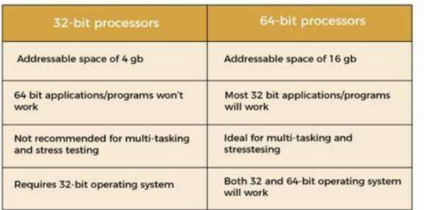

- 32-bit (x86)
- Memory Access: Can address up to 4 GB of RAM.
- Performance: Suitable for basic computing tasks and older hardware.
- Compatibility: Can run 32-bit software and operating systems.
- Registers: Uses 32-bit wide registers in the CPU.
- 64-bit (x64)
- Memory Access: Can address more than 4 GB of RAM, theoretically up to 18.4 million TB.
- Performance: Better performance for demanding applications, multitasking, and modern hardware.
- Compatibility: Can run both 32-bit and 64-bit software and operating systems.
- Registers: Uses 64-bit wide registers in the CPU, allowing for more efficient processing.

- Create a Workspace Environment:

- Click on the Workspace link: MyWorkspace
- Click on the New Workspace Icon
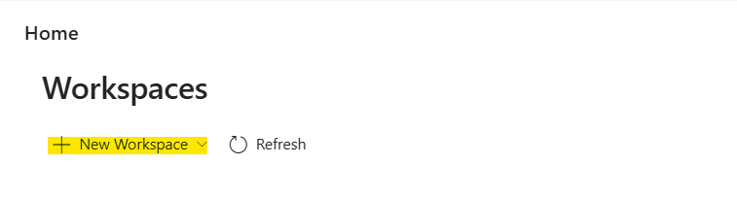
- Click on the template workspace as already a template was created in which it includes all VM, hyper-V, RAM, HD Space, OS etc.
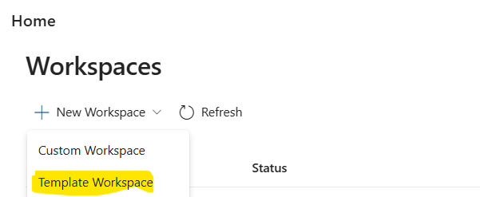
- In the filter, type the nested and you can visible “Windows Commercial Nested Hyper-V Base Template 32GB “and click on next. 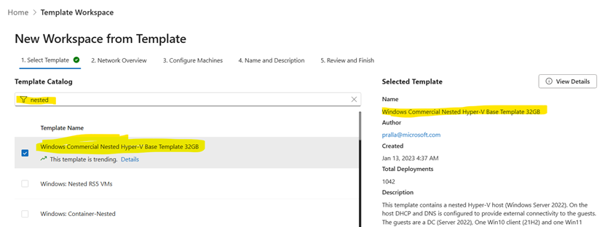
- Click next on step-2,
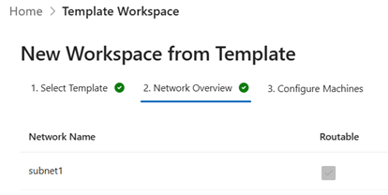
- On step-3, below option should be automatically will come. If not, please close the browser or tab and try from the step-1.
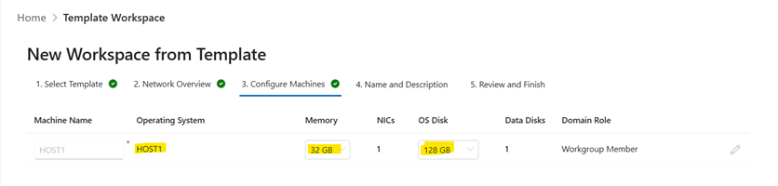
- On step-4, Copy the description and paste somewhere because we have the creds in that,
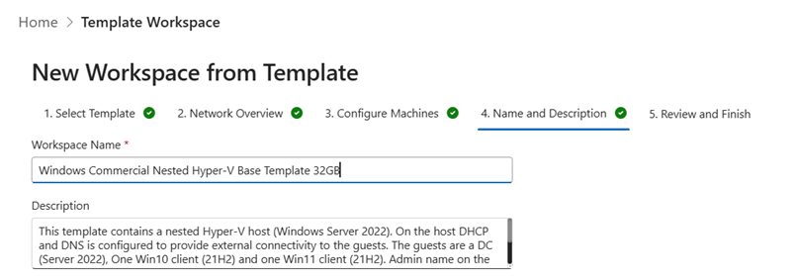
- On step-5, click on the azure geography and select deploy
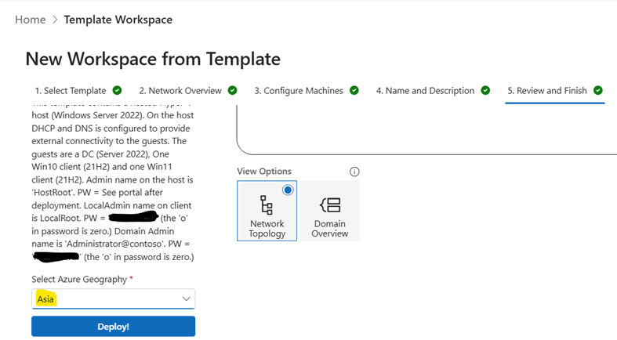
- Host1 was created.
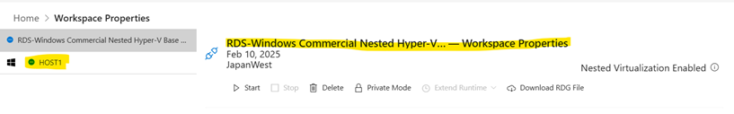
- How to connect the HOST1 in through RDCMan and RDP
- Initially, it is necessary to download the RDG file.
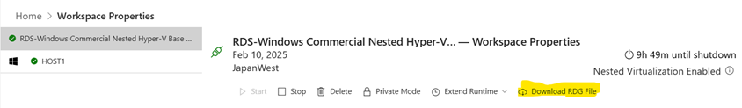
- We cannot access the file without obtaining the necessary permission. Therefore, we need to request Just-In-Time (JIT) access. In this process, we can specify the duration in hours for which we require access to the HOST. Once the JIT access time expires, the RDP session will automatically close.
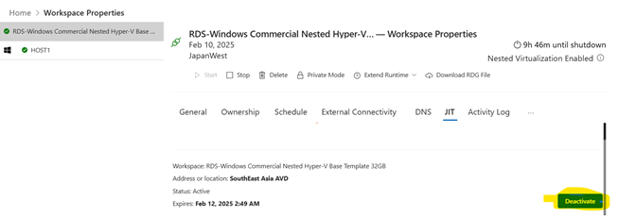
- Open the RDCMan app from the local desktop, click on File, and select the Open option. Next, select the downloaded RDG file.
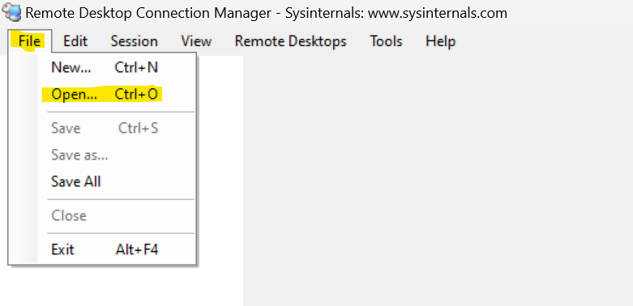
- Next, locate the HOST1 server. Right-click on HOST1 and select "Connect Server".
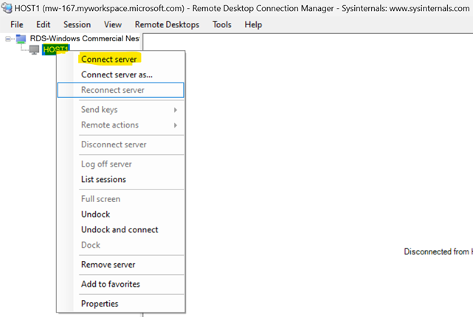
- We need to enter the credentials for the username and password. For that first we need to go the workspace portal. Select HOST1 and choose the connect option where you can view the username and password. Copy the password and paste it into the password field. Afterward, you will be able to login to HOST1. Alternatively, you can login by downloading the RDP file from the HOST1 connect option, which will enable direct access to the server.
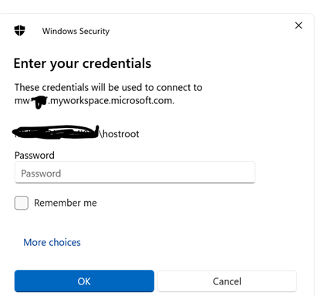
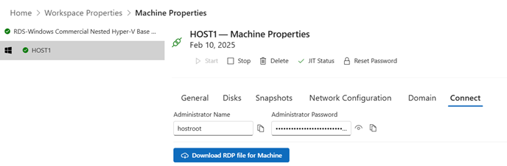
- Then the HOST1 will deploy
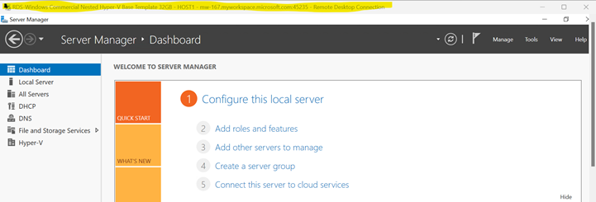

Day-2 : Networking

- How to update the machine
>> local server >> window update >> check update >> restart >> it will take time 20 min

- why we should update the Patches
>> Security, Performance, Compliance, Stability, New Features:
Patch virtual machines to protect against vulnerabilities
3. How to check Ip address and dns server name in machine
>>Cmd >> ipconfig or ipconfig /all

- Try to ping each other machine via Ip address and Machine name
>>cmd >> ping <IP address> and CMD >> ping <hostname>.contoso.local

- What is Nslookup use for
>> Used for querying the Domain Name System (DNS) to obtain domain name or IP address mapping information

- What is firewall :Windows Firewall overview | Microsoft Learn
>> run >> firewall.cpl
A firewall is a network security device that monitors and controls incoming and outgoing network traffic based on predetermined security rules

#Test Environment
If we enable the ipv6 then ping is not working

dc | win10 | win11 | Working/non working
 | enable | enable | not working
 | enable | disable | working
 | enable | enable | Working

to check local host
c>> window >> system32>> driver >> etc

netsh dhcp show server

- How to ping the one machine to other machine .
Step1.: disable the ipv6 in all the machine
Step 2: prefer dns should be dc , win10,11 and ncpa.cpl >> remove the alternate dns
Step3: in hyper-v >> in each machine >> Switch >> we enable the identification
Step4: win 11,10 >> control panel >> network and sharing center >> change advance sharing >> turn on network discory >> and turn on file and print >> Save and change
>> >> same for win 10-A

>> virtual switch >> enable idenfication >> restart the system >> try for ping
>> ip6 enable >> then again try for ping

1. what is different between udp and tcp

**TCP (Transmission Control Protocol)** and **UDP (User Datagram Protocol)** are **transport layer protocols** used to send data over networks, but they operate very differently. Here's a breakdown of how they work and their key differences:

**How TCP Works**
1. Connection-Oriented:
- Establishes a **3-way handshake** (`SYN` → `SYN-ACK` → `ACK`) to create a reliable connection before data transfer.
In the context of TCP (Transmission Control Protocol), the 3-way handshake is a process used to establish a reliable connection between a client and a server before data transfer begins. This process involves three steps: SYN → SYN-ACK → ACK.
- SYN stands for Synchronize. It is used to initiate and establish a connection. The client sends a SYN packet to the server to start the communication and synchronize sequence numbers between the devices
- ACK stands for Acknowledge. It is used to confirm the receipt of the SYN packet. The server responds with a SYN-ACK packet, which is a combination of SYN and ACK, indicating that it has received the SYN packet and is ready to establish a connection
- Terminates the connection with a `FIN` or `RST` packet.
In the context of TCP (Transmission Control Protocol), the terms FIN and RST are used to manage the termination of a connection:
- FIN stands for Finish. It is used to gracefully terminate a connection. When a device sends a FIN packet, it indicates that it has finished sending data and wants to close the connection.
- RST stands for Reset. It is used to abort a connection abruptly. When a device sends an RST packet, it indicates that there is an issue with the connection, and it needs to be terminated immediately.

2. **Reliable Delivery**:
- Guarantees data arrives intact and in order.
- Uses **acknowledgments (ACKs)** to confirm receipt. Missing packets are retransmitted.

3. **Flow & Congestion Control**:
- Adjusts data transmission speed based on network conditions to avoid overwhelming the receiver or congesting the network.

4. **Error Checking**:
- Uses checksums to detect corrupted data and retransmits if needed.

5. **Use Cases**:
- Web browsing (HTTP/HTTPS), email (SMTP), file transfers (FTP), and any application where **data integrity is critical**.

**How UDP Works**
.
UDP (User Datagram Protocol) does not use a 3-way handshake or SYN and ACK packets because it is a connectionless protocol. UDP simply sends packets without establishing a connection, which makes it faster but less reliable than TCP.

1. **Connectionless**:
- No handshake or connection setup. Data ("datagrams") is sent immediately.

2. **Best-Effort Delivery**:
- No guarantees. Packets may arrive out of order, be lost, or be duplicated.

3. **No Congestion/Flow Control**:
- Sends data at maximum speed, regardless of network conditions.

4. **Lightweight**:
- Minimal overhead (smaller headers) and no retransmission delays.

5. **Use Cases**:
- Real-time applications like video streaming (e.g., Zoom), VoIP (e.g., Skype), online gaming, DNS queries, and live broadcasts.

**Key Differences**

Feature | TCP | UDP
Connection | Connection-oriented (handshake required) | Connectionless (no handshake)
Reliability | Guaranteed delivery | Best-effort delivery (no guarantees)
Ordering | Packets arrive in order | No ordering guarantees
Speed | Slower (due to overhead) | Faster (low latency)
Error Checking | Full error checking and recovery | Basic checksum (no recovery)
Congestion Control | Yes | No
Header Size | Larger (20-60 bytes) | Smaller (8 bytes)
Use Cases | Data integrity > Speed | Speed > Data integrity

When to Use Which?
- **TCP**:
Use when you need **accuracy** (e.g., downloading a file, loading a webpage, sending an email).
- **UDP**:
Use when you need **speed** and can tolerate some data loss (e.g., live streaming, gaming, VoIP).
Summary: TCP prioritizes reliability and order, while UDP sacrifices these for speed and simplicity. The choice depends on the application’s requirements!

1.List of ports and their use.

- Port 20 and 21: File Transfer Protocol (FTP) - used for transferring files between a client and server.
- Port 22: Secure Shell (SSH) - used for secure remote login and other secure network services.
- Port 23: Telnet - used for unencrypted text communications.
- Port 25: Simple Mail Transfer Protocol (SMTP) - used for sending emails.
- Port 53: Domain Name System (DNS) - used for translating domain names to IP addresses.
- Port 69: Trivial File Transfer Protocol (TFTP) - used for simple file transfers.
- Port 80: Hypertext Transfer Protocol (HTTP) - used for web traffic.
- Port 110: Post Office Protocol version 3 (POP3) - used for retrieving emails from a server.
- Port 119: Network News Transfer Protocol (NNTP) - used for reading and posting Usenet articles.
- Port 135: Remote Procedure Call (RPC) - used for RPC endpoint mapping.
- Port 137-139: NetBIOS - used for network basic input/output system services.
- Port 143: Internet Message Access Protocol (IMAP) - used for retrieving emails, similar to POP3 but with more features.
- Port 161: Simple Network Management Protocol (SNMP) - used for network management.
- Port 389: Lightweight Directory Access Protocol (LDAP) - used for directory services.
- Port 443: HTTP Secure (HTTPS) - used for secure web traffic.
- Port 445: Server Message Block (SMB) - used for file sharing.
- Port 636: LDAP over SSL (LDAPS) - used for secure directory services.
- Port 1723: Point-to-Point Tunneling Protocol (PPTP) - used for VPN connections.
- Port 3306: MySQL - used for MySQL database connections.
- Port 3389: Remote Desktop Protocol (RDP) - used for remote desktop connections.
- Port 5432: PostgreSQL - used for PostgreSQL database connections.
- Port 5900: Virtual Network Computing (VNC) - used for remote desktop access.
- Port 8080: HTTP Alternate - used for web traffic when port 80 is unavailable.
DHCP uses specific ports for communication between clients and servers:
- UDP Port 67: This port is used by the DHCP server to listen for client requests
- UDP Port 68: This port is used by the DHCP client to receive responses from the server
These ports are commonly used for various applications and services, ensuring proper communication and functionality across networks.

